using System.Collections.Generic;

using System.Windows.Forms;

using System.Linq;

using System.IO;

using System;

namespace Program {

public partial class Form1 : Form {

public Form1() {

InitializeComponent();

}

private void Form1_Load(object sender, EventArgs e) {}

private void chooseFileButton(object sender, EventArgs e) {

openFileDialog1.ShowDialog();

string file = openFileDialog1.FileName;

List<int> numbers = new List<int>();

List<string> words = new List<string>();

FileStream stream = File.Open(file, FileMode.Open, FileAccess.Read);

if (stream != null) {

StreamReader reader = new StreamReader(stream);

string data = reader.ReadToEnd();

string[] split = data.Split(new[] {' ', ',', '.', '?', '!', ';', ':'});

foreach (string word in split) {

int number;

bool isNumber = int.TryParse(word, out number);

if (isNumber) {

numbers.Add(Convert.ToInt32(word));

}

else {

words.Add(word);

}

}

stream.Close();

}

int n = numbers.Count();

numbers.Sort();

int min = numbers[0];

int max = numbers[n - 1];

List<string> AllWord = new List<string>();

List<string> SelectWord = new List<string>();

for (int i = 0; i < words.Count(); i++) {

AllWord.Add(words[i]);

}

for (int i = 0; i < words.Count(); i++) {

AllWord.Remove(words[i]);

for (int j = 0; j < AllWord.Count(); j++) {

if (AllWord.Remove(words[i]) && !SelectWord.Contains(words[i])) {

SelectWord.Add(words[i]);

}

}

}

textBox2.Text += " * Количество чисел в файле: " + n

+ "\r\n * Минимальное число: " + min.ToString()

+ "\r\n * Максимальное число: " + max.ToString()

+ "\r\n * Повторяющиеся слова: \r";

for (int i = 0; i < SelectWord.Count; i++) {

textBox2.Text += SelectWord[i] + " \r ";

}

}

private void saveFileButton(object sender, EventArgs e) {

saveFileDialog1.ShowDialog();

string fileName = saveFileDialog1.FileName;

FileStream stream = File.Open(fileName, FileMode.Create, FileAccess.Write);

if (stream != null) {

StreamWriter writer = new StreamWriter(stream);

writer.Write(textBox2.Text);

writer.Flush();

stream.Close();

}

}

}

}

Test2

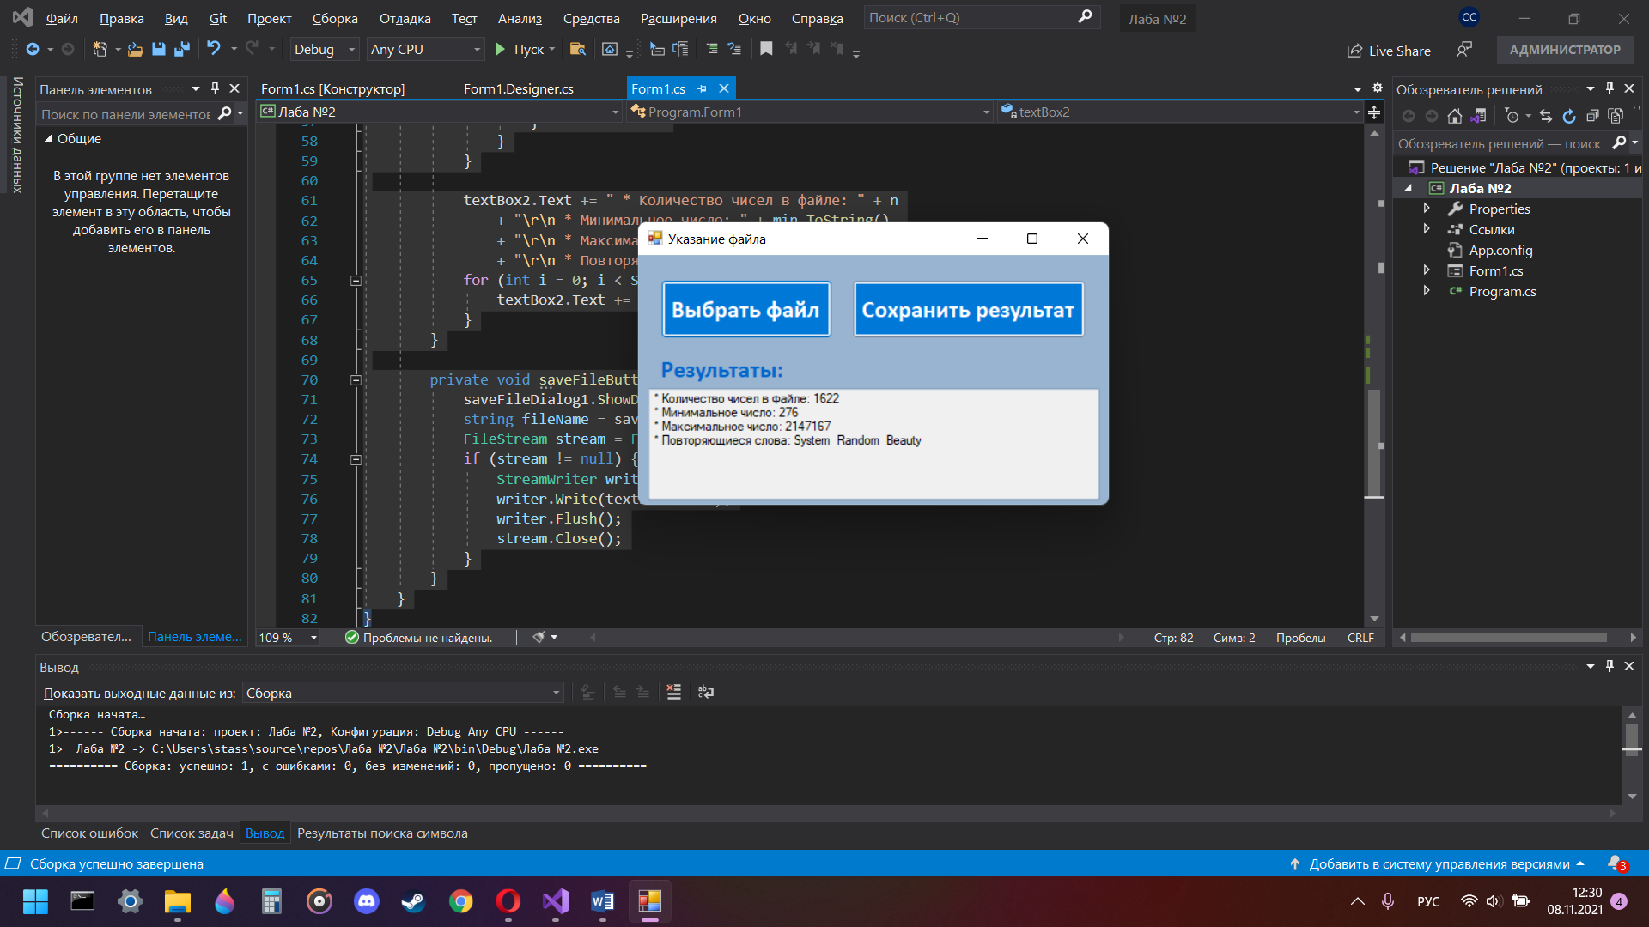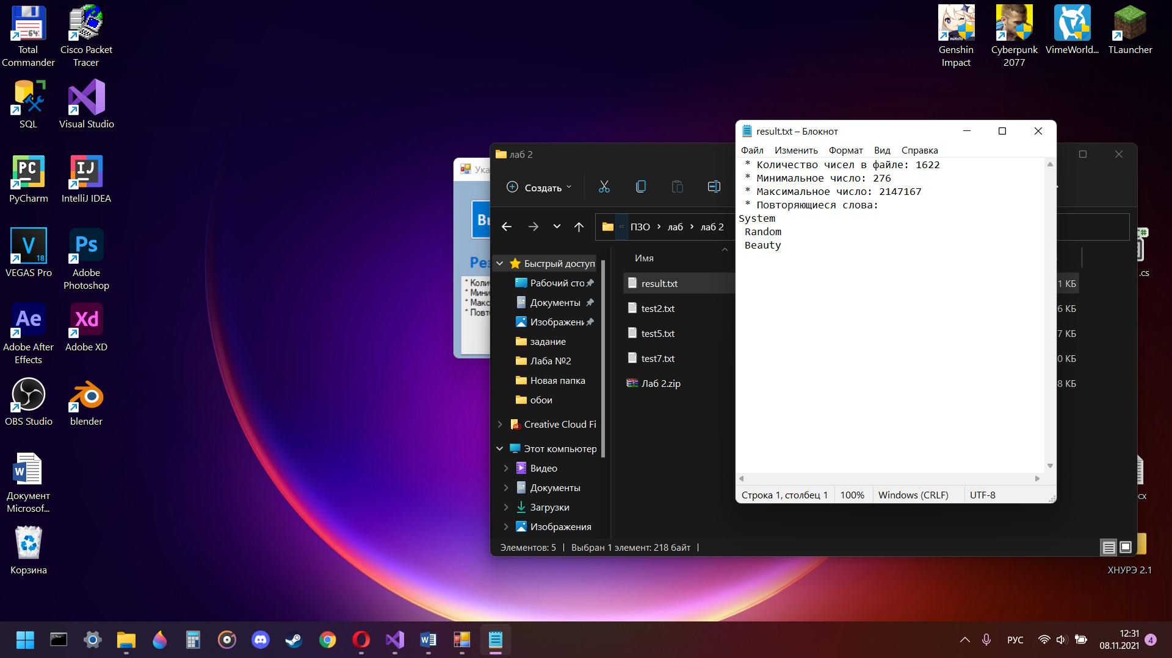

Test5

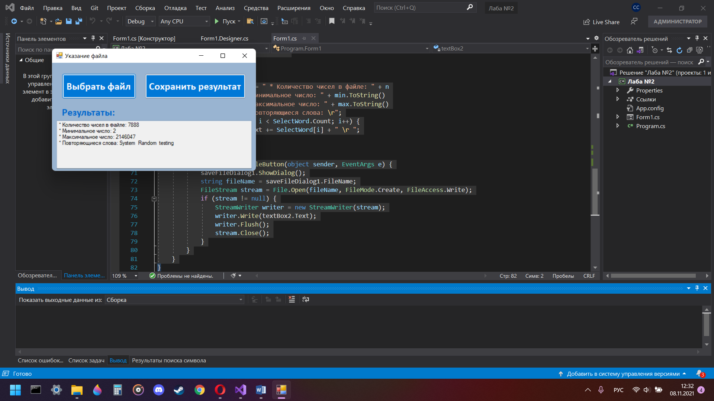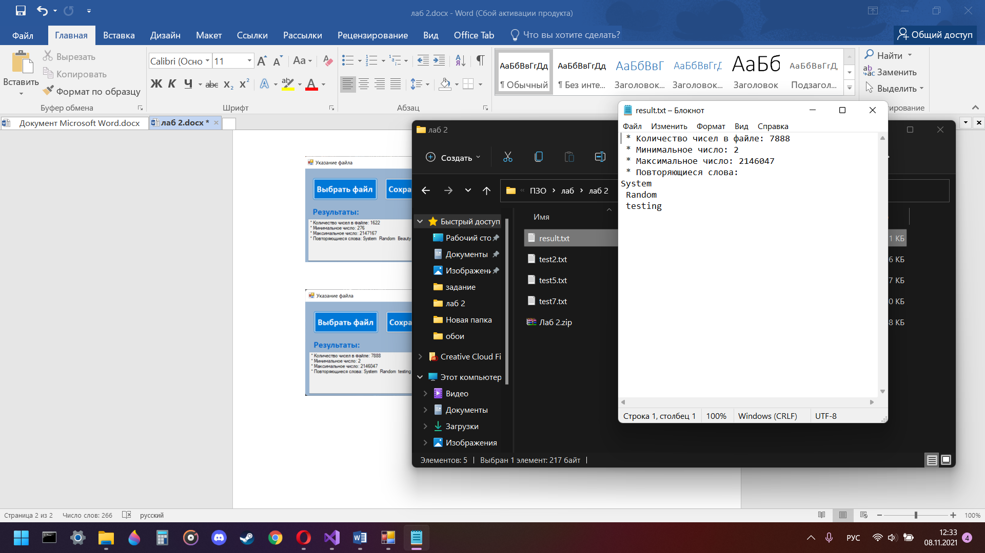

Test7

